Holiday Home Work Class XI : 2024-25

Commerce Stream
ACCOUNTANCY
Prepare Project on Source Documents and Vouchers
Complete Ch-9 (Journal)

BUSINESS STUDIES
Prepare a project file on any one of the following topics -
* Sole proprietorship
* Partnership
* Joint Hindu Family
* Complete notebook upto chapter 2.5

ECONOMICS
* Prepare a project on collection of data ( Data of 10 families with summary)
* Complete notebook upto chapter 6

English
* Prepare Mind maps and complete the pending worksheets of all the lessons & Poems covered by now.
* Learn the shared idioms and proverbs with meanings and frame sentences in note book.
* Listen to the Speech of any 2 prominent personalities & write the same in brief following the format of Speech Writing.

Physical Education
Prepare a investigatory report of BMI (10 Person) as per given instructions.

IT
Prepare a Chart one Topic given below: Transmission Media, Operating System, Network Devices, Topology Cyber Security

Music
make a project file on thaat and it's type.

Science Stream
Biology
1.Prepare investigatory project report on Biology, Select Topic from your syllabus
2.Complete your class note book and write down NCERT question answer

Physics
* Do NCERT unsolved exercise Ch-1,2,3
* Do NCERT solved exercise ch- 1, 2, 3
* Prepare one investigatory Project

Maths
*Prepare the creative project -
"Mathematical properties of elections"
As the General Elections loom, engaging in a project focusing on Election results from the past decade can be enlightening. Did you know the systematic study of elections and voting trends is termed psephology? Dive into the analysis of previous election trends, exploring aspects like party vote shares, the effectiveness of opinion polls, and campaign finance information. Showcase your findings through insightful graphs. This project might spark a genuine interest in psephology and provide an opportunity to explore it as a potential future career option.
**Prepare the notebook according to Ncert Book upto chapter 3 (Exercise 3.2 Trigonometric functions).

Chemistry
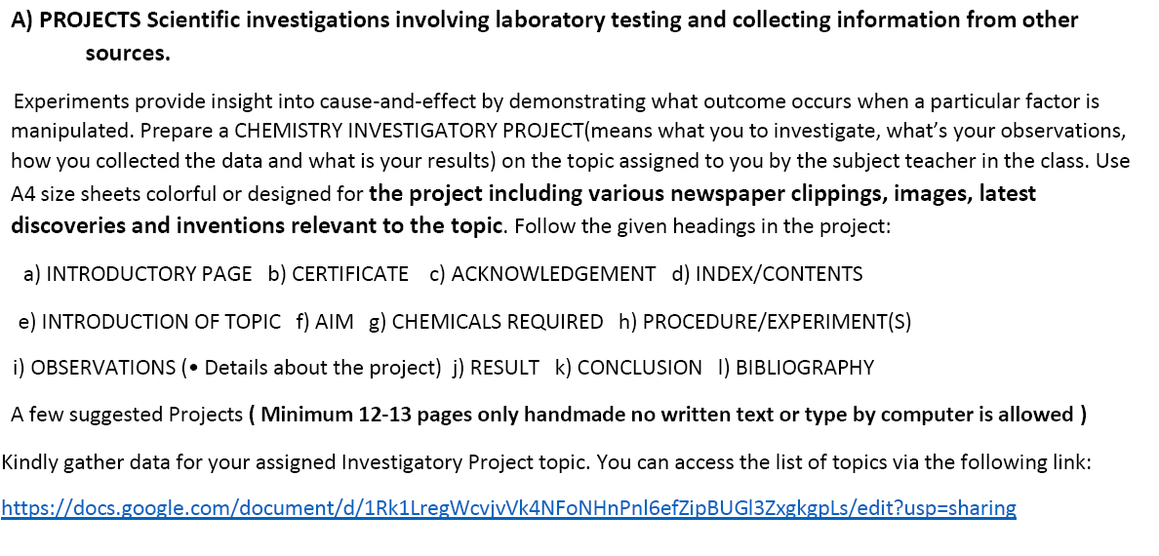
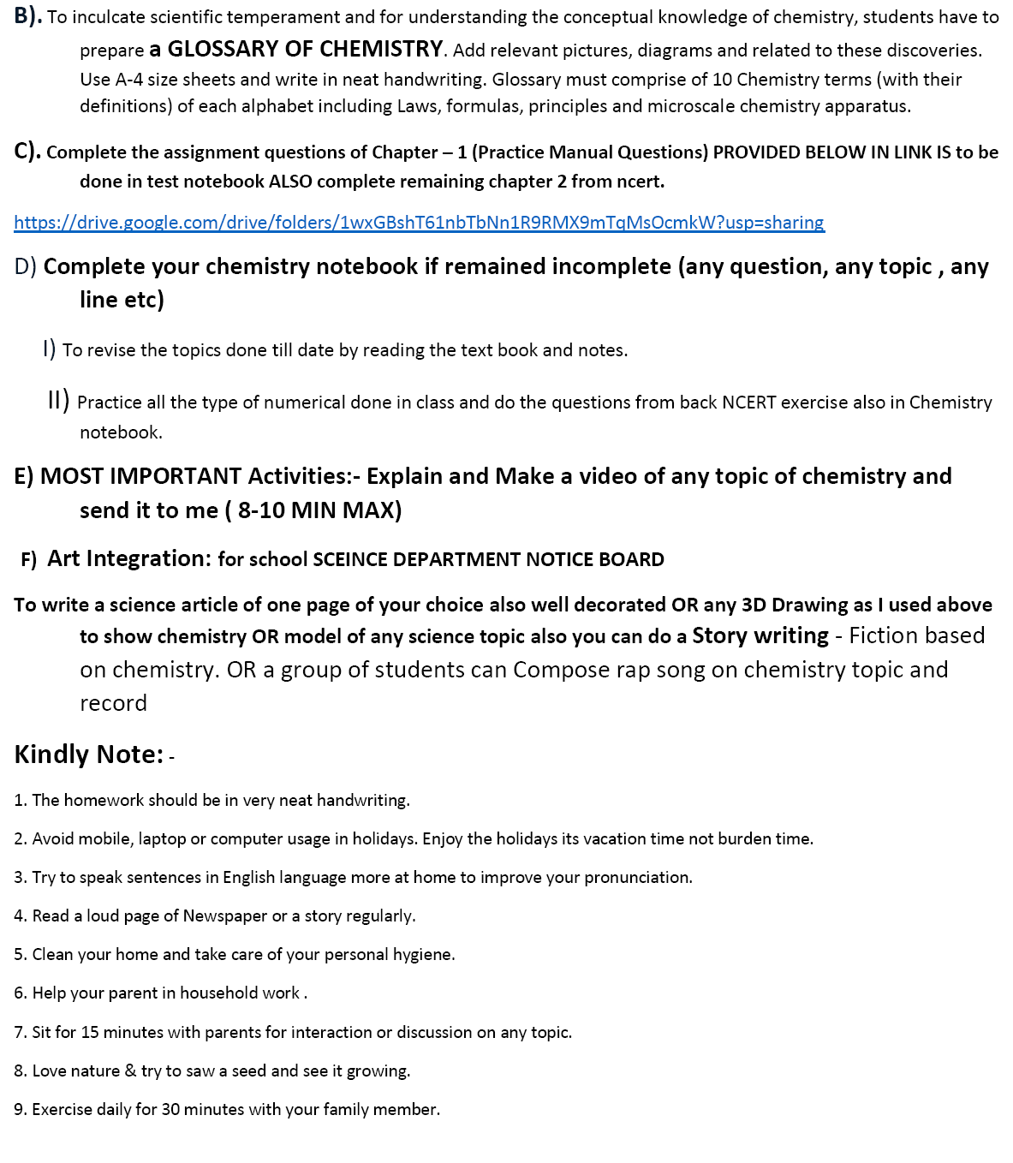
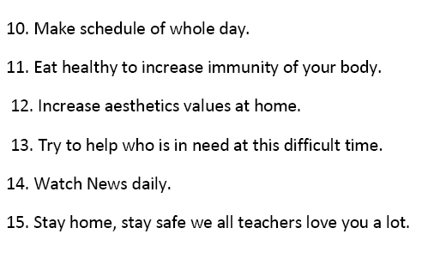

English
* Prepare Mind maps and complete the pending worksheets of all the lessons & Poems covered by now.
* Learn the shared idioms and proverbs with meanings and frame sentences in note book.
* Listen to the Speech of any 2 prominent personalities & write the same in brief following the format of Speech Writing.

Physical Education
Prepare a investigatory report of BMI (10 Person) as per given instructions.

IT
Prepare a Chart one Topic given below: Transmission Media, Operating System, Network Devices, Topology Cyber Security

Music
make a project file on thaat and it's type.

Art Stream

Hindi
1. पठित कविताओं का प्रतिपाद्‌य विषय लिखिए।
2. पठित पाठों का mind map तैयार कीजिए ।
3. अपने आस-पास एक सर्वेक्षण करें और पता लगाएं कि किस आयु वर्ग के और कितने प्रतिशत लोग रेडियो, समाचार-पत्र, टी. वी, सिनेमा या इंटरनेट का प्रयोग समाचार या अन्य जानकारियों के लिए करते हैं। प्राप्त आंकड़ों के अनुसार एक pie chart तैयार कीजिए ।

Political Science
* Prepare Investigatory Project on the topic given by CBSE (Any One)
A . Project Work: 20 Marks
Class will be divided into six groups with six / seven students in each group of 6 students.
TOPIC ALLOTTED
Group I : Making of the Constitution.
Group II : Elections in India.
Group III : Working of the Indian Judiciary System.
Group IV : Social Justice: Are ethics followed in Indian Politics
Group V : Human Rights Act and its gratification in India.
Group VI : Political impact on Indian Legislation.
GENERAL GUIDELINES:
• The project is to be done on inter-leaf sheets.
• The total length of the project will be 20-25 pages.
• Students have to preserve the initial drafts of the project as well as any research papers that they may have used.
• Students have to be prepared to give a presentation of the project in the class.
• A summary / synopsis (one page) of the project has to be prepared covering:
The objective statement ;Their observations and findings The learning outcomes
• Any other learning from this exercise such as skills of teamwork, problem solving,time management, information collection, processing, analysing and synthesizing relevant information to derive meaningful conclusions;
• The projects must be neat and well-presented and must be completely hand-written.
• No whiteners to be used or written matter to be crossed out. In case of any mistakes,redo the sheet.
• Do not number sheets or write dates unless so instructed. ·
• Colour illustrations, maps, charts may be hand drawn or printed (if it is relevant for any aspect of your project) are welcome to make them look attractive.
Suggested Topics
CLASS XI
1. Making of the Constitution.
2. Elections in India.
3. Working of the Indian Judiciary System.
4. Social Justice: Are ethics followed in Indian Politics
5. Human Rights Act and its gratification in India.
6. Political impact on Indian Legislation.
The Project can also be made on any of the topics given in the syllabus of a particular class or any contemporary issues.
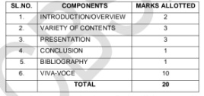
* Complete your Note Book with NCERT Exercise and Extra Question / Answer
*Inculcate the habit of reading newspapers and make short reports for further reference .
* Make a sample paper on Book 1 : Indian Constitution .
Geography
1. Make a Project on Natural Hazards and Disasters
Roll no- (1-10) Topic- Earthquake
Roll no- (11-20) Topic- Tsunami
Roll no- (21-30) Topic- Floods
Roll no- (31-40) Topic- Droughts
2. Prepare a scrapbook for map work, Paste 10 Political map of India and 10 Political map of World.
3. Map work - Locate the following points on India map.
A. Latitudinal extent of India
B. Longitudinal extent of India
C. Standard Meridian of India
D. Tropic of cancer
E. Southern most point of India (Kanyakumari)
4. Complete your Geography Practical work upto sheet no-3

English
* Prepare Mind maps and complete the pending worksheets of all the lessons & Poems covered by now.
* Learn the shared idioms and proverbs with meanings and frame sentences in note book.
* Listen to the Speech of any 2 prominent personalities & write the same in brief following the format of Speech Writing.

ECONOMICS
* Prepare a project on collection of data ( Data of 10 families with summary)
* Complete notebook upto chapter 6

Physical Education
Prepare a investigatory report of BMI (10 Person) as per given instructions.

IT
Prepare a Chart one Topic given below: Transmission Media, Operating System, Network Devices, Topology Cyber Security

Music
Make a project file on thaat and it's type.

